CASE STUDY 4: Water Tank Filling Rate Analysis
Scenario
A water tank is being filled, and sensors record the volume of water (in liters) over time (in minutes). Engineers want to determine:
- The rate at which water is entering the tank
- The total volume accumulated over time
Given Data
Time(min) | Volume(L)
0 | 0
2 | 40
4 | 110
6 | 210
8 | 340
10 | 500

Step 1: Numerical Differentiation (Flow Rate)
Use central difference:
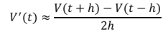
Where: ℎ=2 minutes
Compute flow rate at: 𝑡=2,4,6,8
Step-by-step calculation at each point:
At t = 2 neighbors are t=0 and t=4:
V'(2) = [V(4) – V(0)] / (2 × 2)
= [110 − 0] / 4
= 110 / 4
= 27.5 L/min
At t = 4 neighbors are t=2 and t=6:
V'(4) = [V(6) − V(2)] / (2 × 2)
= [210 − 40] / 4
= 170 / 4
= 42.5 L/min

At t = 6 4 neighbors are t=4 and t=8:
V'(6) = [V(8) − V(4)] / (2 × 2)
= [340 − 110] / 4
= 230 / 4
= 57.5 L/min
At t = 8 neighbors are t=6 and t=10:
V'(8) = [V(10) − V(6)] / (2 × 2)
= [500 − 210] / 4
= 290 / 4
= 72.5 L/min
Note: We cannot compute at t=0 or t=10 because there are no neighbors on both sides.
Step 2: Numerical Integration
Use Trapezoidal Rule:
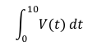
In our case, we add all trapezoids together:
Total = (h/2) × [V(t₀) + 2V(t₁) + 2V(t₂) + 2V(t₃) + 2V(t₄) + V(t₅)]
Then we plug the values (h = 2):
= (2/2) × [V(0) + 2·V(2) + 2·V(4) + 2·V(6) + 2·V(8) + V(10)]
Convert each V(t_{n})’s volumes:
= 1 × [0 + 2(40) + 2(110) + 2(210) + 2(340) + 500]
Calculate:
= 0 + 80 + 220 + 420 + 680 + 500 = 1,900 L*min
Summary table of results
Time(min) | Volume(L) | Flow Rate V¹(t)(L/min)
0 | 0 | --
2 | 40 | 27.5
4 | 110 | 42.5
6 | 210 | 57.5
8 | 340 | 72.5
10 | 500 | --
Integrated total volume (Trapezoidal Rule): 1,900L
Step 3: Visualization
Plot:
- Volume vs time
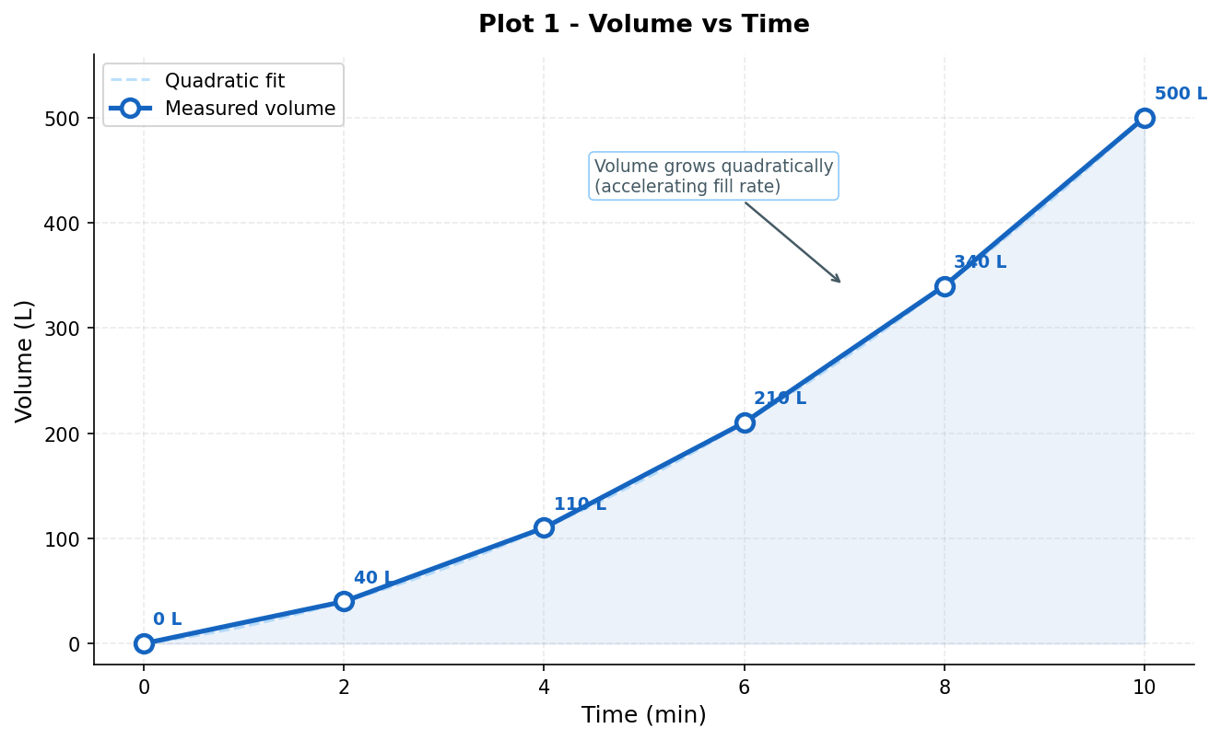

- Flow rate vs time
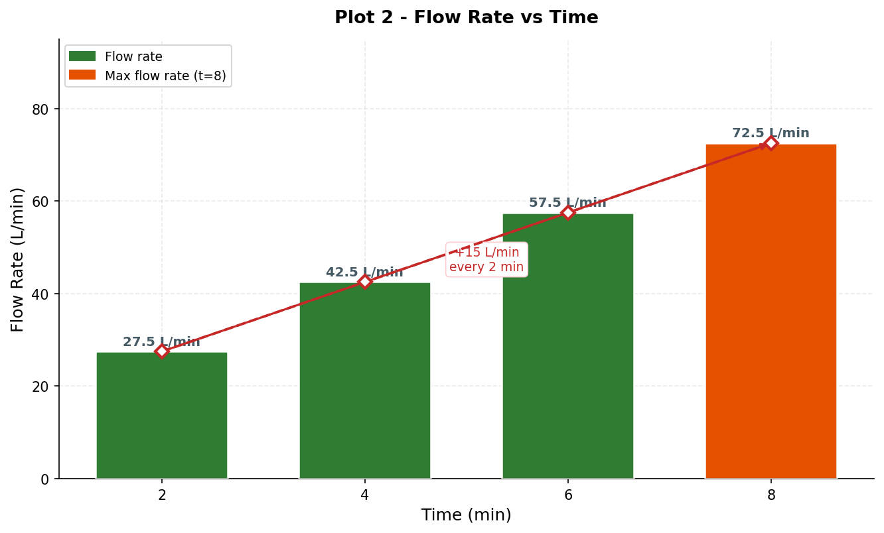

Step 4: Analysis Questions
- Is the flow rate constant?
- No, the flow rate is variable. If the flow were constant, our calculated derivative values would be the exact same across all time intervals. Instead, we see the flow rate steadily increasing from 27.5 L/min at minute 2 all the way up to 72.5 L/min at minute 8.
- When is the inflow fastest?
- Based on our central difference calculations, the inflow is fastest at the end of the recorded period (t = 8 minutes), where it reaches 72.5 L/min. This indicates that the valve filling the tank is being opened wider as time goes on.
- Is the system linear or accelerating?
-The system is accelerating. A linear system would have a constant flow rate (which would look like a straight, diagonal line on your volume graph). Because the flow rate (the speed of the water) is actively increasing over time, the volume of water is accumulating faster and faster.
Summary
For this case study, we successfully analyzed the water tank filling rate by applying numerical methods to the given discrete volume and time data. First, we used the Central Difference formula with a time step of (h=2) minutes to calculate the specific flow rates at the interior time points, discovering that the inflow steadily increased from 27.5 L/min at minute 2 up to 72.5 L/min at minute 8. Next, we applied the Trapezoidal Rule to integrate the volume function over the full 10-minute period, yielding an integrated total area of 1900 L·min. Based on these calculations, we concluded that the tank's filling system is actively accelerating and the flow rate is variable, with the inflow being the fastest at the end of the recorded timeframe.

